(SCD) Assignment # 1

**Q1)**

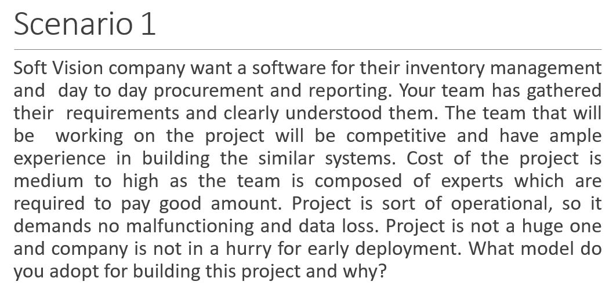

**Ans)** In this scenario the waterfall model will use because the requirements are clear to the stakeholders and they also made similar projects. The project is risk free and it is a small project also, and the cost is not so high. That is the reason the waterfall model will be use.

**Q2)**

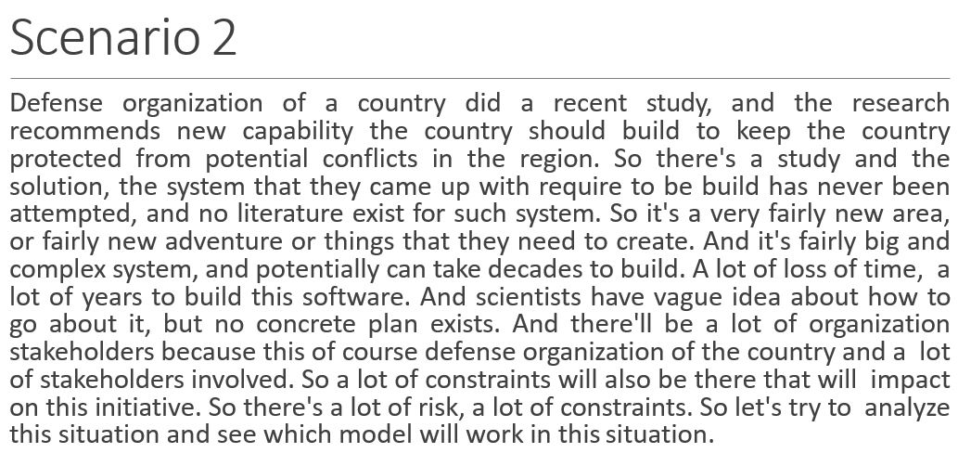

**Ans)** In this scenario the spiral model will use because the team is unsure about the project like they do not know about the requirements and there is no past literature. The system is complex and can take lots of time. the project is long and huge. the scientists have unclear idea of how to start. There will be constraints because of unclear requirements. After this analyzing I prefer the spiral model will be use.